Student - Sng Ming Xiang
1008912
02-137DH Introduction TO DIGITAL humanities
Final project: Frankenstein reimagined

Table of Contents
Project Overview 2
Humanities Engagement and Significance 3
Methodology 5
Results and Stylometric Analysis 8
Limitations 11
Conclusion 12
References 13

Project Overview
This project tests the capabilities of a Natural Language Processing Large Language Model in mimicking the writing style of the gothic style from an 1818 author Mary Shelley. The primary text for this project is Frankenstein the 1818 edition. This study was aimed to use AI to reimagine the text written by Mary Shelley in a different way whilst still trying to maintain the writing style of the original author.
The project plays with the original theme of the 1818 text, modifying the narrative focus from Victor Frankenstein’s characteristic flight response to his actions and aristocratic impunity toward a trajectory of sustained moral accountability. The “pivot” in chapter 12 diverges from the original tragedy, exploring the consequences of a creator who wishes to take responsibility for his creation rather than take off in fear
The introduction of Elizabeth Lavenza’s first-person journal in Chapter I showcases her in an intellectual and morally upright light that was largely absent or mediated through letters in the original canon. The first-person journalling style also mirrors the original letters by Captain Walton, maintaining the essence of the story.
Research questions:
How does providing Victor Frankenstein with a sense of responsibility fundamentally alter the thematic resolution of the novel?
In what ways does centering Elizabeth Lavenza’s independence and moral compass expose the invisible discussion of class and privilege within the original text?
"Within hybrid text, how effectively can stylometric analysis differentiate between original 19th-century prose and the AI-generated narrative interventions?"

Humanities Engagement and Significance
The new version of the text reasons Victor’s initial decision to do nothing as a byproduct of his status at the time and not as a rash cowardly decision. This concept is highlighted throughout the new version of the text. In the original text, Victor describes to be a rather troubled individual and it felt like the original text seemed to use that fact as a reasoning for his decisions. However, the new version gave more depth to the character and points out that his guilt and troubled mindset is a luxury that he can afford due to his status. With Elizabeth’s increased involvement in the text, she also singled out the fact that his social economic status lets him get away with things that others, much like ‘Justine” would not be able to get away with. Elizabeth acted as his moral compass resulting in him making the better decision at the end, moving away from his original character. She has been a key role in allowing him to understand his impact on the less fortunate as a member of a higher social class. Towards the end, there is a sort of a closure in this theme when he used his wealth to establish legal fund for the disenfranchised. He described it as the “truest thing [he has] done with money” The new text allowed the story to have a new added layer in its discussion of wealth and power.
In the AI version, Elizabeth was also a core character with a much more important role in the story. This reflects a more modernized way of writing as opposed to a more traditionally passive style of giving female characters a smaller role in older proses. In the original text, Elizabeth was treated as a mere narrative object given to Victor, however, the AI version gave her a “voice’ and instead was an essential supplement to Victor’s character development.
The AI text also explores the importance of Victor’s involvement in the creature’s life. There is a stark contrast of the creature’s behavior in the new version where Victor decides to take responsibility for the creature as the creator compared to the original when the creature was left to experience the cruel world on its own. In the new version, Victor finally sees his creation as a being with rights and not just a creature. The new story also builds on the concept that all beings are born benevolent and good. It proofs that the creature’s ‘monstrous’ behavior at the start was due to social abandonment. In the new text, the creature and Victor’s relationship became one of understanding which allowed the creature to eventually experience peace and find its place in the world despite the isolation. They were able to find a way to coexist instead of being enemies of each other. This highlights the importance of environment in a person’s or in this case the creature’s development, magnifying the importance of a parental figure in the development of a child. Like Victor and the creature, the new story shows the responsibilities of a parent in the child’s life.
Most people view Natural Language processing LLMs as a tool for efficiency, mostly for summarizing. However, this project uses the AI for literary expansion of texts, giving it the creative license to provide the text with more value. Many historical texts are the product of its time’s biasness, gender for this instance, however, AI is used here to correct this bias and modernize the text to be more inclusive and giving depth to characters that would have otherwise have not be given much thought. Since the original model was trained on modern, balanced data, even though it was refined to mimic the writing style using Mary Shelley’s text, most of its logic still reflects the modernized thinking. Hence, we can use the AI to refine olden texts, giving it a more modern feel.

Methodology
The project started with training the Llama-3.1-8B LLM on Mary Shelley’s texts. Firstly, the texts were retrieved as text files from the Project Gutenberg webpage.
Dataset creation
The model was trained on a collection of Mary Shelley's prose retrieved from Project Gutenberg (see References for full bibliographical details). The specific eBook IDs utilized for the script were #63339, #63338, #63337, #18247, #56665, #15238, and #84.
Google Gemini was then used to generate a script to preprocess the texts to be used as datasets. The script finds standardized legal and header markers used in the original text files and removes licensing information and transcriber notes. It also removes “meta texts” that describes the book but is not part of the text like “content, chapter, letter”. It also removes unessential information like numbers or roman numerals. It also collapses triple newlines to double newlines to preserve paragraph breaks while removing massive gaps. It eliminates whitespace to preserve character-to-word ratio. Finally, it combines all the text into one file for training, with source headers for each section.
Model training in Unsloth
To facilitate ease of training for the model, Unsloth library was used. Unsloth provides optimized Triton kernels and manual backpropagation logic that significantly reduces memory overhead and accelerates training speed. The library uses QLoRA which loads the model in 4-bit precision to reduce the model’s VRAM footprint. Low rank Adaptation (LoRA) freezes the 4-bit base model and trains only tiny adapter layers, acting as a stylistic ‘filter’ layer that adapts to the style of Mary Shelley. The training phase used Supervised Fine-tuning Trainer to train the model. The learning rate was optimized at $2 {10}^{-4}$ to prevent catastrophic forgetting, retaining of the original base of the model. Training was done in batch sizes and gradient accumulation to simulate larger batches.
Determining new storyline
Instead of getting the model to rewrite the full story, the original texts were split into the different scenes and analyzed to determine which part should be modified by the AI. Afterwards, these were the chapters that was modified.
Chapter 1: Replaced the original letters by Captain Walton with Elizabeth’s first-person journal. It focuses on her internal reflections regarding the Frankenstein family’s socioeconomic status in Geneva. She also reflects on Victor’s character and how he lacks practical accountability for his actions
Chapter 2: AI version was generated showing the initial reaction of Elizabeth following Victor’s departure but eventually the original version was kept. Note: In the analysis the AI version was used but it messed with the flow of the story, so the original was kept in the manuscript.
Chapter 6: The chapter was about Victor in Justine’s trial, contemplating on whether he should speak up but realized that he feared the ‘exposure’ more than he feared for her life.
Chapter 7: The chapter depicted Elizabeth’s internal response to Justine’s arrest. Noted, the original version was used in the final version of the manuscript.
Chapter 12: The chapter focuses on Victor’s psychological shift while he was in Orkney islands. This chapter also represented the main shift from the original story.
Chapter 13: Victor used his wealth to purchase the safety of his creations to travel to the high north.
Chapter 14: They relocated to a remote estate in Chamonix to prepare for their final exile.
Chapter 15: On their wedding night, Victor confesses to Elizabeth of his sins, hence leading to Elizabeth getting involved in sheltering the creatures.
Chapter 16: Elizabeth reflects privately on Victor’s actions and decided to take over the situation. This was the chapter that the creatures were given names and humanized. Adam and Eva by the AI
Chapter 17: The group sail north under the discretion of Captain Walton. This chapter details Elizabeth and Eva interactions.
Chapter 18: The group arrives at Arctic islands and Victor the creatures with the tools and shelter for survival. It was also the moment where they part way, leaving the creatures to live in the Arctic.
Chapter 19: A time skip which showed Victor and Elizabeth living a secluded life and Victor using his fortune to establish a legal defense fund for the disfranchised.
Script generation
Google Gemini was used to generate the script to be used to get the trained model to generate the story. This script managed the memory constraints for the AI and ensured that the AI kept to the narrative throughout the story. It consisted of four primary mechanisms.
Model initialization and Weight merging
The script utilized the Parameter-efficient fine-tuning (PEFT) library to fuse the base model and the LoRA adapters into a unified model optimized for the text generation.
Algorithmic chunking
This fixes the context window limitations of the AI by constraining each processing block of 300 words, ensuring it does not lose track of the plot.
Contextual memory (Narrative stitching)
Within each processing block, the script automatically fed the model the previous outputs. This allows the AI to keep in context during the text generation
Hyperparameter Tuning for Stylistic Generation
The Temperature was set at 0.8 – 0.85 allowing for creativity whilst ensuring that the model does not go off track.
The Top-p was at 0.9-0.92 to filter out highly improbable vocabulary choices.
Introduced a repetition penalty to prevent the AI from getting stuck and looping the same phrase.
Editing
With the new manuscript, another script was generated to fill in the missing chapters, and some manual editing was done to ensure coherence in the story. Some decisions were made to not use the AI chapters or to add sections that were manually typed to address plot holes that arose with the new chapters. Lastly, all was compiled in a word document.
Evaluation
To evaluate the generated output, the 'stylo' package in RStudio was utilized. The analysis was configured to measure the 500 Most Frequent Words (MFWs) using the Classic Delta distance to map structural bifurcations between the original 1818 text and the AI-generated chapters.

Results and Stylometric Analysis
The result of the generation is a mixture of a few chapters of the original text and some of the AI generated chapters which changed the flow of the original story completely.
After which I performed Stylometric analysis between the chapters. Since the generation was done on full chapters, the original chapters act as an internal control group for the experiment, where the new chapters will represent the experimental variables. The analysis was done to see if there is a distinctive difference between the unchanged chapters and newly generated chapters. Note that there was one or two manually added sentences within the story, which served to maintain the narrative flow of the story. This will not have much of an impact on the analysis since the percentage of the manually typed sentences to the entire story is insignificant.
To validate the stylistic fidelity of the generated texts, stylometric analysis was performed on the new version of the text. The new text is split into the separate chapters and processed using the ‘stylo’ package in RStudio.
The cluster analysis is as follows:

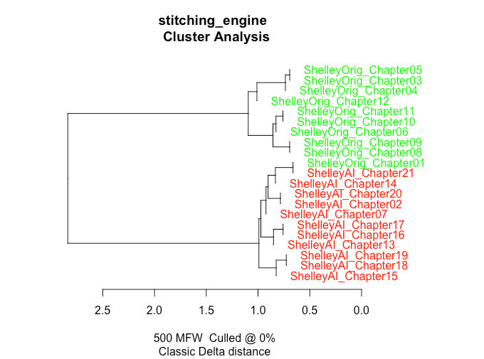
Despite the AI managing to adopt Mary Shelley’s Gothic style vocabulary, the stylometric analysis reveals that the model failed to fully replicate the author’s distinctive style. The Cluster analysis uses the 500 Most Frequent Words (MFWs) with classic delta distance performed on synthesize corpus. The resulting graph depicts a definitive structural bifurcation. The graph shows the original text and the AI generated text having separate clusters, showing a distinct difference between the two.
The Principal Components Analysis (PCA) is as follows:

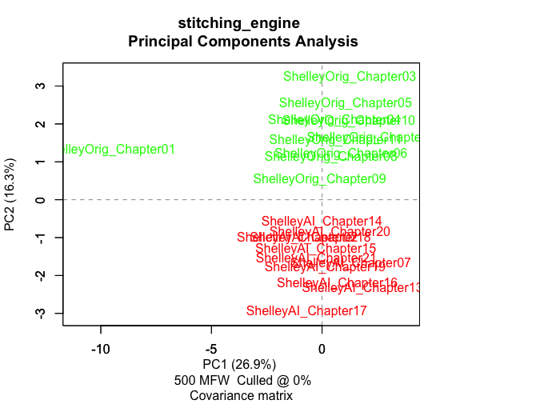
The plot shows a distinctive separation along the PC2 axis, showing a 16.3% variance. Mary Shelley’s text occupies the positive section whereas the AI chapters are contained in the negative. The plot also show model consistency as the highlighted red AI chapters are all tightly grouped centered around 0 in the PC1 axis.
The PCA analysis was able to successfully detect the shift in literary mode, from third person to first person. As seen with chapter 1 which was Elizabeth’s journal. It This is identified as a significant outlier along the PC1 axis with about 26.9% variance. It is important to note that despite the chapter being AI generated it was labelled incorrectly as original here. However, this shows that despite the incorrect label, the software was able to still identify the anomaly and pushed it to the far left.
However, it is also notable that the anomalous chapter lies on the positive side of the PC2 axis. In this chapter, it discusses about Elizabeth’s childhood and Frankenstein’s family, hence it may have shared many of the words which overlaps with the early chapters(original) discussing early life of Frankenstein. The AI managed to accurately mimic the vocabulary used by Mary Shelley in this chapter but was differentiated by its unique narrative structure.

Limitations
While the model was successful trained using the texts from Mary Shelley. There were many limitations faced during the generation of the main text.
Due to the Llama-3.1-8B model being trained using 4-bit quantization using the unsloth framework, the model used would not be able to perform at its full capacity using the data available. However, this project had to adapt to the VRAM limitations of available computer hardware.
Another major limitation is the context window bottleneck. Initially there were a lot of issues faced with the AI going out of context and completely start talking about things not related to the story. The AI had issues with following its own storyline and a lot of tweaks had to be made to ensure that the AI was able to generate a coherent story with a controlled number of tokens. Most of these were solved to allow the AI to perform properly but most of the chapters generated is significantly shorter than the actual story chapters. This was also the reason why a lot of the original story was retained. The AI had to be limited to a smaller load in other to ensure that it performed to its full capacity.
Even with the changes and limitations put upon the AI to ensure proper performance, after reading the story, there was still slight incoherence which had to be rectified manually.
At the end of this project, considering the results of the analysis, it is evident that the AI was able to mimic the vocabulary used by Mary Shelley at a passable rate. However, the analysis proved that it was incapable of mimicking her subconscious use of syntax and style. This might also have been because of the limited training data since Mary Shelley did not have many literary works to train the AI on.
There was also an outlier that showed that when switching literary modes, the model’s structural mimicry was broken. Hence, this proves that the AI is highly brittle when pushed outside of a standard narrative voice.

Conclusion
This project validates that the LLM is still unable to fully mimic an author’s literary footprint and current style analysis is still able to differentiate text generated by AI. With the listed limitations, AI still needs a long way before they can start replacing human authors.
This project also explored a different direction in the humanities aspect by rewriting Frankenstein with a different focus in themes such how the wealthy were treated, the environments effect on a person and taking responsibility in scientific creation and works. It also showed that older works tended to harvest biasness from their times that may not be present in the modern world.

References
Dataset
Frankenstein; or, the modern Prometheus by Mary Wollstonecraft Shelley. (2026, February 10). Project Gutenberg. https://www.gutenberg.org/ebooks/84
The Last Man by Mary Wollstonecraft Shelley. (2022, October 29). Project Gutenberg. https://www.gutenberg.org/ebooks/18247
Mathilda by Mary Wollstonecraft Shelley. (2022, September 25). Project Gutenberg. https://www.gutenberg.org/ebooks/15238
Tales and Stories by Mary Wollstonecraft Shelley. (2021b, December 14). Project Gutenberg. https://www.gutenberg.org/ebooks/56665
Valperga Volume 1 (of 3) by Mary WollstoneCraft Shelley. (2024, October 18). Project Gutenberg. https://www.gutenberg.org/ebooks/63337
Valperga Volume 2 (of 3) by Mary Wollstonecraft Shelley. (2024, October 18). Project Gutenberg. https://www.gutenberg.org/ebooks/63338
Valperga Volume 3 (of 3) by Mary WollstoneCraft Shelley. (2024, October 18). Project Gutenberg. https://www.gutenberg.org/ebooks/63339
Software
Han, D., & Danilushkin, M. (2024). Unsloth (Version 2024.4) [Computer software]. GitHub. https://github.com/unslothai/unsloth
Eder, M., Rybicki, J., & Kestemont, M. (2016). Stylometry with R: A Package for Computational Text Analysis. The R Journal.
Model
Meta AI. (2024). Llama 3.1-8B [Large language model]. https://ai.meta.com/blog/meta-llama-3-1/

Frankenstein; or, the modern Prometheus by Mary Wollstonecraft Shelley. (2026, February 10). Project Gutenberg. https://www.gutenberg.org/ebooks/84
project gutenberg - Bing. (n.d.). Bing. https://www.bing.com/
Han, D., & Danilushkin, M. (2024). Unsloth (Version 2024.4) [Computer software]. GitHub. https://github.com/unslothai/unsloth
Eder, M., Rybicki, J., & Kestemont, M. (2016). Stylometry with R: A Package for Computational Text Analysis. The R Journal.
Meta AI. (2024). Llama 3.1-8B [Large language model]. https://ai.meta.com/blog/meta-llama-3-1/

